**TURF BOOKING SYSTEM**

PROJECT REPORT SUBMITTED IN PARTIAL FULFILMENT OF THE REQUIREMENTS FOR THE AWARD OF DEGREE OF

##### BACHELOR OF COMPUTER APPLICATIONS TO

**MARIAN COLLEGE KUTTIKKANAM AUTONOMOUS**

##### Affiliated to

**MAHATMA GANDHI UNIVERSITY, KOTTAYAM**

By

**ABHINAND ANIL**

**(21UBC102)**

**AMALNATH S**

**(21UBC112)**

GUIDED BY

#### Mr. Santo Cherian



##### DEPARTMENT OF COMPUTER APPLICATIONS MARIAN COLLEGE KUTTIKKANAM (AUTONOMOUS) PEERMADE - 685531

**OCTOBER 2023**

**DECLARATION**

We, **Abhinand Anil [ Reg.no 21UBC102] and Amalnath S[Reg.no 21UBC112]** certify that the Mini project report entitled **“ Turf booking”** is an authentic work carried by us at Marian College Kuttikkanam Autonomous. The matter embodied in this project work has not been submitted earlier for the award of any degree or diploma to the best of our knowledge and belief.

Signature of the Student

**ABHINAND ANIL [ Reg.no 21UBC102]**

**AMALNATH S [ Reg.no 21UBC112]**

**BONAFIDE CERITIFICATE**

This is to certify that this project work entitled **“TURF BOOKING SYSTEM”** is a bonafide record of work done by **ABHINAND ANIL [ Reg.no 21UBC102] & AMALNATH S [Reg.no 21UBC112] at MARIAN COLLEGE KUTTIKKANAM AUTONOMOUS** in partial fulfilment for the award of **Degree of Bachelor of Computer Applications** of **Mahatma Gandhi University, Kottayam.**

This work has not been submitted elsewhere for the award of any other degree to the best of our knowledge.

Head of the Department Internal Guide

##### Dr. Rajimol A Mr. Santo Cherian

Dept. of Computer Applications Dept. of Computer Applications

Marian College Kuttikkanam Autonomous Marian College Kuttikkanam Autonomous Peermade – 685531 Peermade- 685531

Submitted for the Viva-Voce Examination held on

##### Department Seal

**External Examiner**

**ACKNOWLEDGEMENT**

“Gratitude is a feeling which is more eloquent than words, more silent than silence.” In undertaking this project, we needed the direction, assistance and cooperation of various individuals and organizations, which is received in abundance with grace of God, without their unconstrained support, the project could not have been completed.

If words are considered as the symbol of approval and token of acknowledgement, then let the following words play the heralding role of expressing my gratitude.

We wish to acknowledge my sincere gratitude to Principal **Prof. Dr. Ajimon George, Marian College Kuttikkanam Autonomous,** for all their efforts and administration in educating us in this premier institution.

We extend my gratitude to **Dr. Rajimol A,** Head of the Department of Computer Applications, who is a constant source of inspiration and whose advice helped us to complete this project successfully.

We express our deep sense of gratitude to our internal project guide, **Mr. Santo Cherian**, for his profound guidance for the successful completion of this project.

With great enthusiasm We express our gratitude to all the faculty members of Department of Computer Application for their timely help and support.

Finally, we express our deep appreciation to all our friends and family members for the moral support and encouragement they have given to complete this project successfully.

Abhinand Anil

Amalnath S

# ABSTRACT

## ABSTRACT

The "Turf Booking System" project is a web site created for a turf (artifical ground for playing football/cricket) that enables customers to reserve slots, make payments online, view available time slots, and submit feedback. This system is Automated to replace the complicated manual turf booking process that is currently in use. The system has two user modules: Admin and Customer panel;

The administrator can login by giving the Admin ID and password. Admin can keep track the bookings, update the remaining time slots, update the amount, etc.

The customer can book the turf for a particular time slot, check the availabilty of time slots, make payment using credit card and submit feedbacks. Customers can also monitor booking status and download the receipt of booking after payment session.

The system also provides the option to the user to give reviews and feedbacks. This system saves the time of manual booking and can avoid customer rush to turfs. Customers can book turfs to get their slots reserved online at any time. This system is developed using programming languages such as PHP, HTML, CSS, and JavaScript and the MYSQL.

The Turf Booking System is a vital innovation in the sports industry, simplifying turf reservations and management. By automating processes, improving user experiences, and promoting transparency, it is poised to revolutionize how sports enthusiasts’ access and enjoy turf facilities.

## TABLE OF CONTENTS

#### TITLE PAGE NUMBER

**ACKNOWLEDGEMENT ABSTRACT**

#### INTRODUCTION

**1**

* 1. About the Project 2
  2. Purpose and Scope 2
  3. Existing System 2
  4. Proposed System 3

1. SYSTEM ANALYSIS

4

* 1. Problem Definition 5
  2. Advantages of Proposed System 5
  3. Feasibility Analysis 5
     1. Operational Feasibility 5
     2. Technical Feasibility 6
     3. Economical Feasibility 6
  4. Recommended Implementation 6

1. SYSTEM REQUIREMENT SPECIFICATION
   1. Introduction 8
   2. Purpose 9
   3. Scope
      1. System Statement of Scope 9
   4. Technical Overview 10
      1. User Characteristics 10
   5. Stated Requirements
      1. General Requirements 10
      2. Inputs 11
      3. Processing 11
      4. Outputs 11
   6. External Interface Requirements
      1. User Interface 11
      2. Software Interfaces 11
2. SYSTEM DESIGN
   1. Introduction 14
   2. Design Methodology
      1. Input Design 14
      2. Output Design 15
      3. Code Design 15
      4. Database Design 16
   3. Major Design Constraints
      1. General Constraints 17
   4. System Architecture and Process Flow 18
   5. Structured Chart 19
   6. Module Details 22
   7. Performance Issues 22
   8. Security Issues 22
   9. Table Design 23
3. CODING
   1. Introduction 29
   2. Selection of Software 29
   3. Coding Phase 30
      1. Coding Standards 30
4. TESTING AND IMPLEMENTATION
   1. Introduction 32
   2. Testing 32
      1. Test Plan 32
   3. Testing Methods 33
      1. White Box Testing 33
         1. Unit Testing 34
      2. Black Box Testing 34
         1. System Testing 34
         2. Integration Testing 36
         3. Validation Testing 36
      3. Output Testing 37
      4. User Acceptance Testing 37
   4. Implementation 37
5. ENHANCEMENTS AND MAINTENANCE
   1. Maintenance 40
   2. Enhancements 40
6. CONCLUSION
   1. Conclusion 42

BIBILIOGRAPHY 43

APPENDIX - SAMPLE SCREEN SHOTS 44

# INTRODUCTION

## INTRODUCTION

### ABOUT THE PROJECT

The Turf Booking System is developed for the simplification of manuals works done by the employees in turf and also to enable online turf slot booking and payment. It is difficult for customers to book slots manually at the turf and it’s also difficult for the turf employees to keep records of all the bookings and payment. This system automates the entire booking process so that booking and record management can be easily done.

The system consists of two users the admin and the customer. The admin can login using the login credentials and have the functionality to modify and manage the records in database. The customers can view all the available slots and book their slots for specific time and also customers can make payment online through credit card.

### THE PURPOSE AND SCOPE

This system provides automation of entire Slot booking and payment process in a turf through internet. The main objective of the system is to avoid the difficulties in manual turf booking and provide a reliable, secure, efficient, and user-friendly environment to customers and admin. Using a web-based system, the better management of records can be done and also duplication and mistakes in data can be avoided. This system has a user-friendly interface so that the customers can easily and efficiently use its features.

This project is a transaction related information storing project which will be used by a single

T u r f for online movie ticket booking through the internet.

The objectives of the system are:

* + - Enable online turf slot booking.
    - Efficient management of records.
    - Minimize the time consumed in manual process.
    - Efficient and faster service.
    - Better customer experience.

### EXISTING SYSTEM

The Existing system is a manual booking process done by employees of the turf. In this system the customers have to get slots manually from the turf and the records are maintained in hand-written registers. The system is time consuming and human efforts are more. The retrieval of the information is not as easy as the records are maintained in registers. This application requires

correct feed of input into the respective field. If any error occurs while entering the data, the entire data needed to be corrected and write down once again. Each section needed to be entered in different books of records.

Limitations of existing system are:

* + - Manual booking at turf.
    - Difficulties in modifying and maintaining records.
    - Time consuming.
    - Not user friendly.

### PROPOSED SYSTEM

The proposed System is to overcome the drawbacks of the existing system. This system is a web- based system which automates the entire turf slot booking process. The system provides user friendly interfaces for both the admin and customer.

The admin has the authority and privileges to do the system maintenance. Admin can monitor, modify and manage the records. Admin is provided with the username and password so that it is highly secured. The admin can maintain slot details and user booking details. The users at any time can view the required information like whether slots are available for a particular time. They can collect all information regarding time slots.

# SYSTEM ANALYSIS

## SYSTEM ANALYSIS

### PROBLEM DEFENITION

All projects are feasible if unlimited resources and infinite time have given. The development of a computer system may encounter difficulties due to lack of resources and of the delivery dates. It is necessary to evaluate the feasibility of the project at the earliest possible time to avoid such problems.

### ADVATAGES OF PROPOSED SYSTEM

* The system avoids data duplication and data inconsistency by several verification and validation process.
* More user friendly than the existing system.
* Fast and efficient data processing.
* New functionalities and features can be added without much alteration.
* Secured than the existing system.
* Specification of the automated system helps to accumulate all the details of the customer
* The New system appropriately decreases time consumption compared to the existing system.
* Better customer experience.

### FEASIBILITY ANALYSIS

The feasibility analysis is a comprehensive evaluation of a proposed project that evaluates all aspects critical for its success. The system will be evaluated for its practicality. A feasibility study is a preliminary exploration of a proposed project or undertaking to determine its merits and viability. A feasibility study aims to provide an independent assessment that examines all aspects of a proposed project, including technical, economic, and financial considerations. The feasibility study can be classified into the following categories:

1. Operational Feasibility
2. Technical Feasibility
3. Economic Feasibility

#### OPEERATIONAL FEASIBILITY

The Operational feasibility is the analyzing of the proposed systems capability against the requirements. Since the new system provides high performance in terms of processing speed, and better record management compared to the existing system its operational. The proposed system offers complete automation of the turf booking process thus the human involvement can be

reduced. The faster processing capabilities can help management in taking timely actions and in reducing workload.

After the feasibility, the analyst has to formulate the problem. Whenever there is a problem defined in clear terms, then only the analyst can solve it using the necessary steps. This will help him to modularize the problem. Hence this stage of system study and problem formulation places an important role in system development life cycle.

#### TECHNICAL FEASIBILITY

Technical feasibility also involves the evaluation of the hardware, software, and other technical requirements of the proposed system. The software used is PHP, HTML and MySQL. If the necessary requirements are made available with the system, then the proposed system is said to be technically feasible.

#### ECONOMICAL FEASIBILITY

Although an initial investment has to be made in terms of software and hardware, the proposed system aims to process information efficiently, saving time and money. The existing system is manual, which increases the chances of incorrect data entry and takes a lot of time. Thus, the benefits acquired out of the system are sufficient enough for the project to be undertaken.

### RECOMMENDED IMPLEMENTATIONS

The analyst collects data from two principle sources: 1. Written documents.

2. Data from the persons, who are involved in the operation of the system under study.

The different fact-finding techniques are: 1. Data carriers

2.Personal interviews 3. Observations 4.Research

##### Data Carriers

In this step the analyst gathers and organizes all documentation related to data carriers for the system under investigation. Examples of data carriers are forms, records, reports, manuals and procedures.

##### Personal Interviews

An interview is a person-to-person communication. The analyst is more of a receiver than a sender when conducting an interview. The interviews are helpful for the analyst to explain the actual aim of an interview. The analyst is primarily seeking information. Therefore, he must be a good listener. Interviews are critical because people are the most important ingredients of a system.

##### Observation

In this method the analyst observes the operation of the on-going system and begins to formulate questions and draw conclusions on the basis of what he observed. Skilled analysts are able to observe things and recall it in a quick way.

##### Research

The final fact-finding techniques, research is of particular importance when a new application is being considered because it is a method of simulating creative approach to the problem solving. All the fact-finding methods that are discussed are in house research.

##### Techniques Used

In our project the fact-finding techniques used is data carriers and interviews to collect data for computerizing the existing system. Data carriers gather forms used for registration, organize all documentations related to the system under investigation. Interview is done to collect information regarding the existing system and also to clear the drawbacks.

# SOFTWARE REQUIREMENT SPECIFICATION

## SOFTWARE REQUIREMENT SPECIFICATION

### INTRODUCTION

A software requirements specification (SRS) is a comprehensive description that outlines the purpose and environment of the software currently under development. The SRS serves as a detailed document, capturing what the software is intended to do and how it is expected to perform. It is the starting point for development activities and remains a challenging aspect of software engineering. These requirements encompass both functional and non-functional aspects, depending on the specific needs. Interaction between customers and stakeholders is crucial to fully understand customer requirements.

### PURPOSE

The purpose of this document is to bridge the communication gap among the client, users, and developers in the software development process. It serves as a comprehensive description of the software requirements, capturing the intended purpose and environment of the system. By accurately specifying the client and user needs, the software requirements specification (SRS) guides the development process, reduces development costs, and helps ensure the delivery of high-quality software. This document also acknowledges the challenges in software requirements. specification, considering the diverse perspectives and needs of the stakeholders involved. Overall, the SRS aims to facilitate effective communication, align expectations, and provide a foundation for successful software development.

### SCOPES

#### STATEMENT OF SCOPE

The scope of a turf automation (booking) system is to provide a comprehensive and user-friendly software application or online platform that facilitates the efficient management and booking of turf fields or sports facilities. The system aims to streamline the booking process, enhance user experience, and optimize the utilization of turf resources. The project includes front-end and back-end development, as well as requirements gathering, system design, implementation, testing, deployment, and maintenance. The Goal of the turf booking system is to streamline the booking process, improve customer satisfaction, increase revenue, and optimize the management of turf fields. The system's scope can be customized to meet the specific needs and workflows of the organization or facility managing the turfs.

### TECHNICAL OVERVIEW

#### USER CHARACTERSTICS

The Turf Booking system has two user modules: Admin and Customer panel. The administrator can login by giving the Admin ID and password. Admin can keep track the bookings, update the remaining time slots, update the amount, etc. The customer can book the turf for a particular time slot, check the availabilty of time slots, cancel the booking, make payment using credit card and submit feedbacks. Customers can also monitor booking status and download the receipt of booking after payment session. The system also provides the option to the user to give reviews and feedbacks.

### STATED REQUIREMENTS

#### GENERAL REQUIREMENTS

The system has 2 main modules and sub-modules associated with each main module.

#### ADMINISTRATION PANEL

**- Login**

The login module of our Turf booking website allows the admin to access admin functionalities. The Admin can log in using their provided credentials. The login form includes fields for the username and password. Upon successful login, the admin is redirected to the admin panel. Already the admin details are stored in the database and there is no sign-up page for admin.

**-Booking Management**

The admin can keep track the bookings, Remaining slots, etc. The admin can also look into the feedback section provided by the users.

**-Slot Management**

*The admin can add new time slots, delete the slots,

Etc.

**-Admin management**

The admin can add new admin, update admin, delete admin, etc.

#### CUSTOMER

Users are directed to home pages directly. On the client's homepage, they can access various services related to slot reservation, slot viewing, change booked slot, payment and feedback submission. The homepage includes buttons to navigate to different sub-modules such as book slot, slots, and Feedback

**- Booking**

In this module, clients can book the available slots for specified time. They can book their desired Slots and proceed to the payment process

**- Slots**

In this module, clients can view the slot list and book directly by selecting a slot for a particular time. There is no booking cancellation option available.

**- Payment**

During the booking process, clients will make the payment for their selected slots. They will provide their payment details and confirm the booking.

**- Feedback**

Clients have the option to provide remarks for the turf services. They can post their genuine Reviews.

#### INPUTS

The system collects booking details, feedback, etc from the users. The system also collects the payment details of users who booked the turf.

#### PROCESSING

- The system performs comprehensive data validation to ensure accurate and valid data entry for feedback, and booking details.

- It general reports based on the turf bookings, providing insights into the usage and trends of the website.

- Specific data formats are enforced for the input fields, ensuring consistency and integrity of the entered information

#### OUTPUTS

For Users:

- Receipt of booking

- Slot availability

- Payment details

- Feedback view

For Admin:

- Payment details

- Slot view

- Bookings view

- Feedback view

### 3.6 EXTERNAL SOFTWARE REQUIREMENTS

##### USER INTERFACE

The user interface of this turf booking system will be intuitive, user-friendly, and visually appealing to ensure a smooth and enjoyable user experience. The display page will be designed with an intuitive layout, pleasant colors, and clear

navigation to enhance usability.

##### 3.6.2 HARDWARE INTERFACE

The system can be accessed using a computer, Smart phone, or any device with internet connectivity. No additional external hardware is Required.

Hardware Specifications:

- Processor: Minimum Intel Pentium or equivalent

- RAM: Minimum 256 MB or higher

- Hard Disk Drive: Minimum 100 MB free disk

space

- Keyboard: Standard QWERTY keyboard

- Printer: Compatible printer for document

printing, if needed.

**3.6.3 SOFTWARE INTERFACES**

##### Software specification

- Operating System: Compatible with Windows 10 or higher.

- Database Management System (DBMS): Utilizing Microsoft SQL Server 2008 or a compatible version.

- Development Tool: Utilizing Atom version 1.60.0 or a suitable programming environment.

These specifications ensure a user-friendly interface, hardware compatibility, and seamless integration with the required software components for the system to operate efficiently.

# SYSTEM DESIGN

## SYSTEM DESIGN

### INTRODUCTION

The purpose of design phase is to plan a solution of the problem specified by the analysis phase. This phase is the first step in moving from the problem domain to solution domain.

System design describes the desired features and operation in detail, including screen layouts, business rules, process diagrams, pseudo code and other documentation.

In this phase, the software’s overall structure and its nuances are defined. In terms of the client/server technology, the number of tiers needed for the package architecture, input design, output design, the database design, the data structure design etc. are all defined in this phase. Analysis and design are very crucial in the whole development cycle. Any glitch in the design phase could be very expensive to solve in the later stage of the software development. So much care is taken during this phase.

The logical system of the product and the physical characteristics of the system are designed during this phase. The operating environment is established, major resources. Everything requiring user input or approval must be documented and reviewed by the user. The physical characteristics of the system are specified and a detailed design is prepared.

The subsystem identified during design is used to create a detailed structure of the system. Each subsystem is partitioned into one or more design units or modules. Detailed logic specifications are prepared for each software module. The logic of the module is usually specified in a high-level design description language, which is independent of the target language in which the software will eventually be implemented.

A good design must consider:

* **Prompt:** should be simple and clear to intuitively lead the user to an expected outcome.
* **Memory load:** Studies show that, under normal circumstances, users have a short-term memory of approximately six words. Ideally, the number of choices of users to select should be four or less. Otherwise, callers become confused and forget the choices presented to them.
* **Service reaches ability:** It is not pleasant for a person to go through a large number of steps before he reaches a service. Users start to get impatient with more than five steps. Minimize the number of steps a caller must take to reduce frustration.
* **Navigation:** Provide a way to navigate back and forth between various dialogue steps. The user should be able to go to different parts of the dialog easily.
* **Phonetic similarity:** Provide a clear set of choices for user to select. Avoid choices with similar pronunciation.
* **Error handling:** Humans make mistakes. Graceful error handling decreases dependency on operators.
* **User update:** Let the user know what is going on and keep him engaged. For the general design one or more potential design are propose and broadly sketched. Then these alternatives are presented to the users, who choose the design that best suits their requirements while staying within the project constraints.

Detailed design stage is specification for the user interface, database, programs, hardware, and training and system documentation. Several structured techniques are used during the design phase. To design the software components, the designer transforms the automated processes in the physical data flow diagram into a program structure chart, which decomposes software processes into detailed modules and shows control path between modules.

### DESIGN METHODOLOGY

#### INPUT DESIGN

In the input design, the user-oriented inputs are converted into computer recognizable format. The collection of input data is the most expensive part of the system in terms of equipment used, time and number of users involved. Input design is the processes of converting user-oriented inputs to a computer-based format. The goal of designing input data is to make data entry as easy, logical and free from errors as possible.

Input design is the link between the information system and the users and the skip necessary to put transaction data in to a usable form for processing. Instructing the computer to read data from a written printed document can activate the activity of putting data into the computer for processing or it can occur by keying data directly into the system. The design of input focusing on controlling the amount of input required, controlling the errors, avoid delay extra steps, and keeping the process simple. System analysis decides the following input design details:

* + - * What data to input
      * What medium is to use
      * How the data is arranged and coded
      * Data items and transaction needing validation to detect error occurs. Activities
      * performed as part of input design are:
      * Data recording
      * Data verification
      * Data conversion
      * Data validation
      * Data correction

#### OUTPUT DESIGN

Output design is a process that involves designing necessary outputs that have to be used by various users according to requirements. Designing computer should proceed in well thought out manner. The term output means any information produced by the information system whether printed or displayed. When analyst design computer output, they identified the specific output that is needed to meet the requirement.

Computer is the most important source of information to the users. Efficient intelligent output design should improve the system relationship with the user and help in decision making. When designing the output, system analyst must accomplish the following:

* + - * Determine the information to present
      * Arrange the information acceptable format

The output design is the key to the success of any system. Output is the key between the user and the sensor. The output must be concerned to the system’s working, as it should. Output design consists of displaying specification and procedures as data presentation. User is never left with the confusion as to what is happening without appropriate error and acknowledges message being received.

#### CODE DESIGN

The coding step is a process that transforms design into programming language. It translates a detail design representation of software into a programming language realization. The code design should be done in such a way that the lines of code used in the software should be minimum for the specified design of the solution. The coding should be in modularized manner.

When code is placed in a module, one may hide it from view and give those executable statements a name (the name of the function or procedure). Information hiding is a good thing when it enhances the understanding of a program by letting to focus on a higher level of abstraction. Information

hiding is a bad thing when it obscures one’s understanding of a program. This usually happens when the name for the module is not chosen accurately.

In this software, the modularized approach is used. Different functions are created for different operations. The name of the module is chosen such a way that it describes what it does, i.e. the name gives the action performed by the module.

#### DATABASE DESIGN

The details about the relevant data that came into play in the system are identified according to the relationship the tables are designed by following the standard database design methods. The dative for each data in the table is defined. For optimum design of database to have better response time, to have data integrity, to avoid the redundancy and for security of the database tables created and analyzed.

A database system can be defined as a representation of an information system in a computer. The general theme behind a database is to handle information as an integrated whole. A database is a collection of interrelated data stored with minimum redundancy to serve many users quickly and efficiently. The general objective is to make information access easy, quick, inexpensive and flexible for the user. In database design, several specific objectives are considered:

* + - * Controlled redundancy
      * Ease of learning and use
      * Data independence
      * More information at low cost
      * Accuracy and integrity
      * Recovery from failure
      * Privacy and security
      * Performance

The scheme is the view that helps us the DBMS decide what data in storage it should act upon as requested by the application program. The subschema is concerned with a relatively small part of scheme. In database design, several views of data must be considered along with the persons who use them. The logical view is what the data look like, regardless of how they stored. The physical view is the way data exists in physical storage. It deals with how data are stored, accessed or related to other data in storage. The logical view is the users view the programmer’s view and the overall logical view, called a schema.

This project has used a main database having different tables, based on which the operations can perform well.

### MAJOR DESIGN CONSTRAINTS

* + 1. **GENERAL CONSTRAINTS**

### Time

Time is so far the biggest restriction or constraint for our project as we only have around one month to finish entire project. It is very important for us to watch the time we spend over every phase of the software development project.

#### Employee Skills

Employees programming and design skills is also one of the restrictions. It does not have as big of an impact on the project.

### SYSTEM ARCHITECTURE AND PROCESS FLOW

#### CONTEXT DIAGRAM

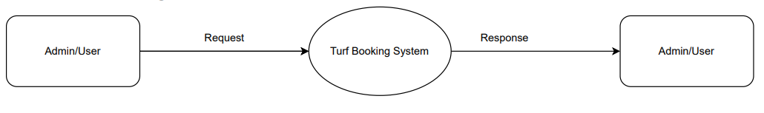

#### ADMIN

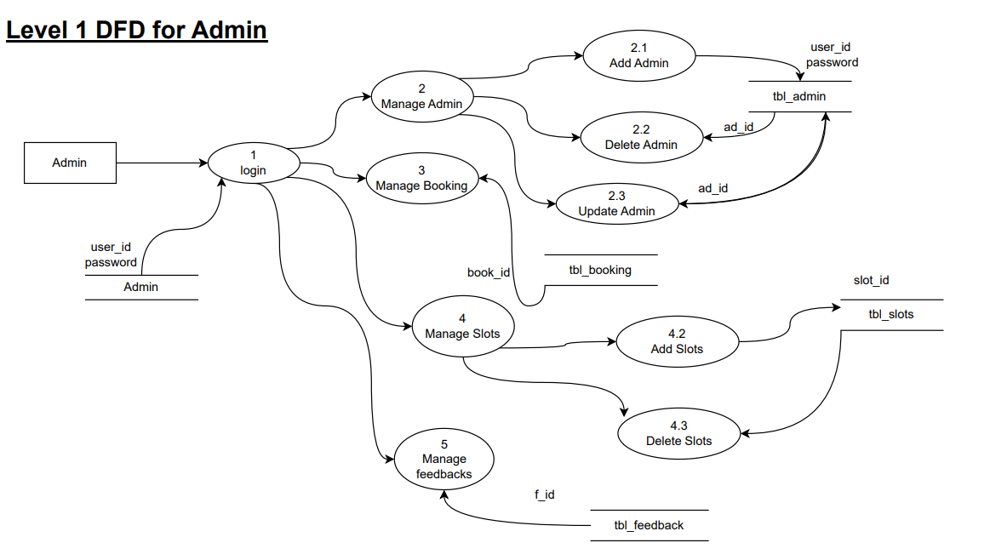

#### USER

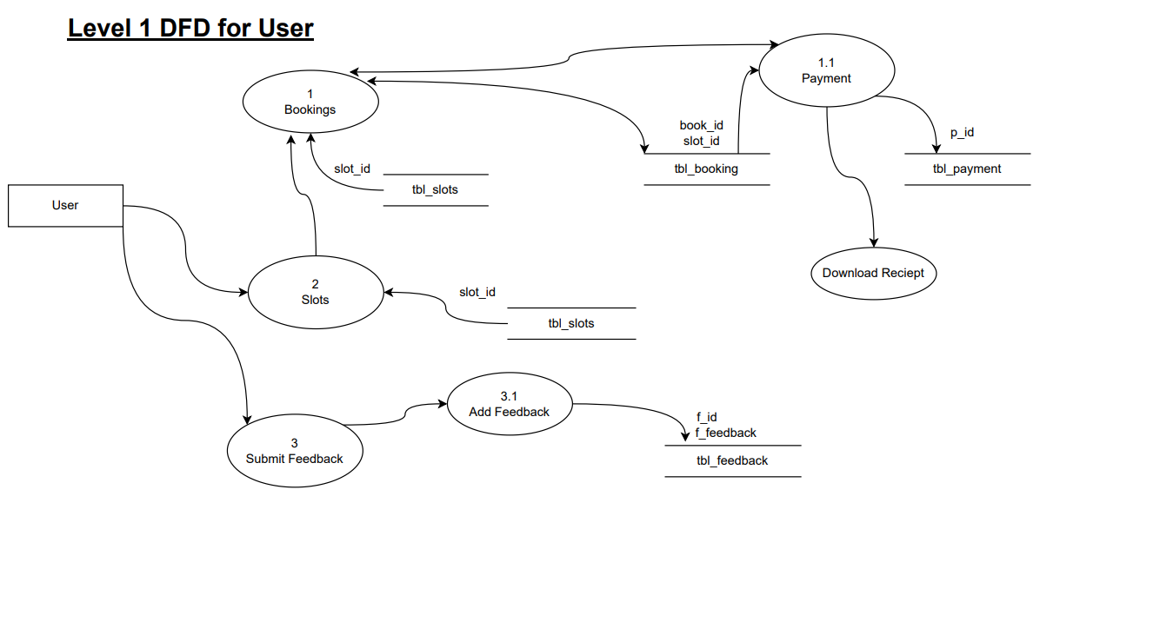

### MODULE DETAILS

The major processes of turf booking system is divided into two major modules and sub modules following them. The first module is the **ADMIN**, which deals with the back- end interface and the second module is the **CUSTOMER VIEW**, which deals with the front interface.

#### ADMINISTRATION

The **ADMINISTRATION** module is handled by the admin whose functionalities includes:

**Admin login**- Admin can login using login credentials (username and password).

**Admin Dashboard –** Shows number of slots booked and remaining slots.

**Manage Slots** – Here admin can add new slots, delete existing slots.

**Manage Booking**– View and manage bookings done by customers.

**Manage Admin**– add new admin, delete existing admin and update admin details.

**Manage Feedback** – View and manage reviews given by customers about the turf.

#### CUSTOMER VIEW

The **CUSTOMER VIEW** module deals with the interface viewed and handled by the customer. It performs functionalities including:

**Home** - Shows the list of currently available time slots.

**Booking** - Shows the list of currently available time slots. Customer can book slots and make payment here.

**Feedback–** Customer can submit review about the turf.

### PERFORMANCE ISSUES

This system should have at least 256 MB of RAM. The OS must be Windows XP or higher.

### SECURITY ISSUES

This software not allows entering an unauthorized user. Verification using username and password is done to prevent the entering of unauthorized access.

### TABLE DESIGN

1. **Table Name: tbl_admin -** holds the admin information

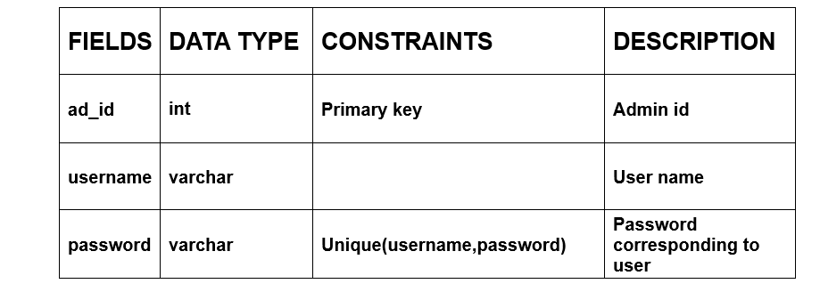

1. **Table Name: tbl_slot -** holds slot details.

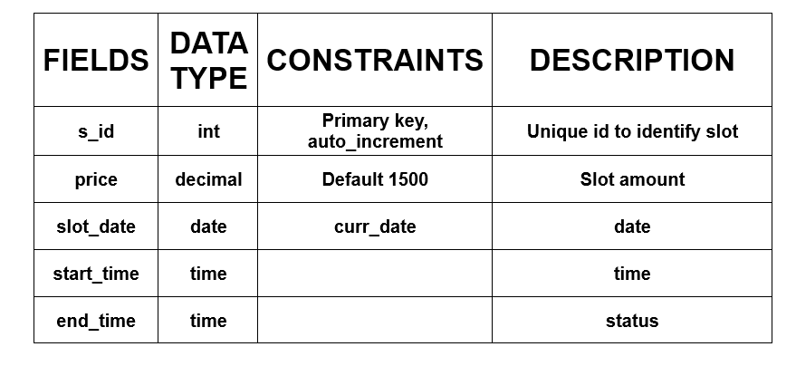

**3.Table Name: tbl_slot -** holds slot details.

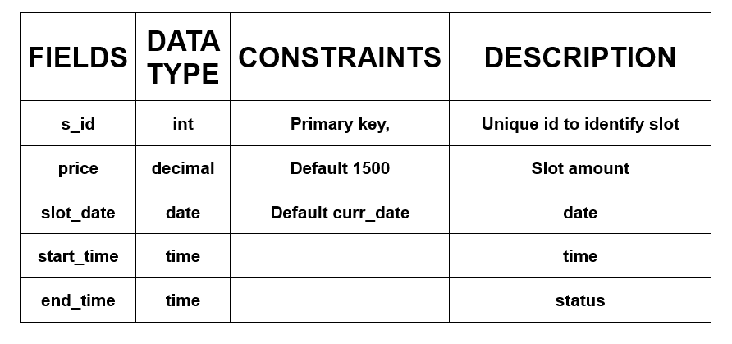

**4. Table Name: tbl_booking-** holds booking details

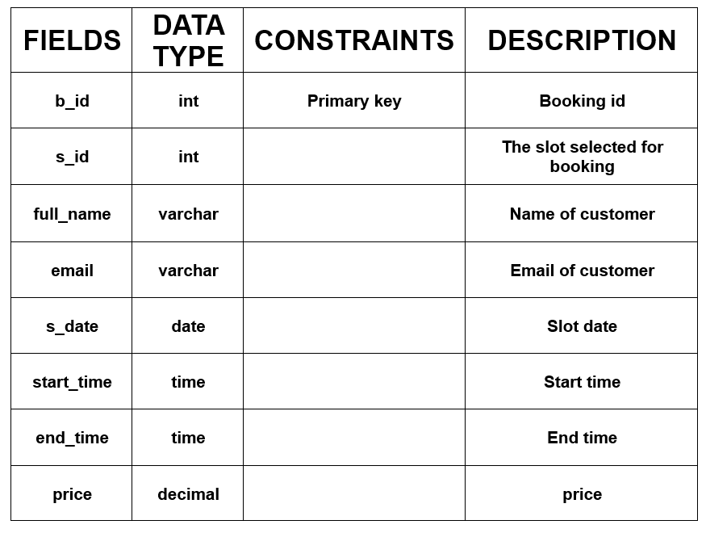

**5.Table Name: tbl_feedback –** holds feedbacks.

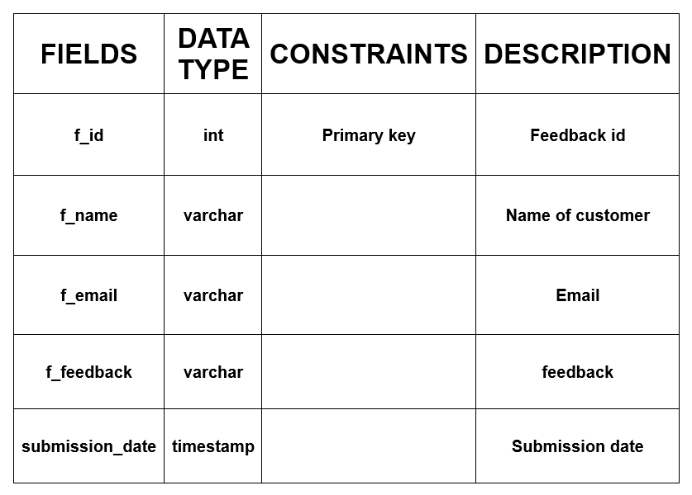

**6.Table Name: tbl_payment –** holds payment details

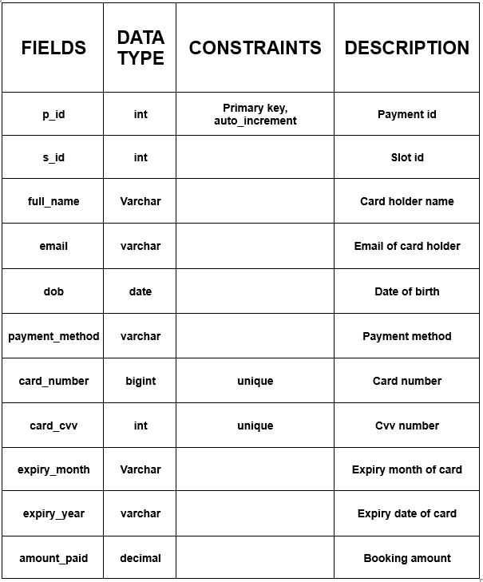

# CODING

## CODING

### INTRODUCTION

Implementation is the stage of the project when the theoretical design is turned into a working system. The implementation stage is a system project in its own right. It includes careful planning, investigation of current system and its constraints on implementation, design of methods to achieve the changeover, training of the staff in the changeover procedure and evaluation of the changeover method.

### SELECTION OF SOFTWARE PHP

PHP is a server scripting language, and a powerful tool for making dynamic and

interactive Web pages. PHP is a widely-used, free, and efficient alternative to competitors such as Microsoft's ASP.

* + - PHP is an acronym for "PHP: Hypertext Preprocessor"
    - PHP is a widely- used, open-source scripting language
    - PHP scripts are executed on the server
    - PHP is free to download and use

#### MySQL

* + - MySQL is a database system used on the web
    - MySQL is a database system that runs on a server
    - MySQL is ideal for both small and large applications
    - MySQL is very fast, reliable, and easy to use
    - MySQL uses standard SQL
    - MySQL compiles on a number of platforms
    - MySQL is free to download and use

#### JavaScript

* + - JavaScript is the world's most popular programming language.
    - JavaScript is the programming language of the Web.
    - JavaScript is easy to learn.

##### CSS

* + - CSS is the language we use to style an HTML document.
    - CSS describes how HTML elements should be displayed.

### CODING PHASE

The goal of the coding or programming phase is translating the design of the system produced during the design phase into code in a given programming language, which can be executed by a computer and that performs the computation specified by the design.

The coding phase affects both testing and maintenance profoundly. The coding phase does not affect the structure of the system; it has great impact on the internal structure of modules, which affects the testability and understands ability of the system.

The goal of the coding phase is to produce clear simple programs. The aim is not to reduce the coding effect, but to program in a manner so that testing and maintenance costs are reduced. Programs should not be constructed so that they are easy to write; they should be easy to read and understand. Reading programs is a much more common activity than writing programs. Hence, the goal of the coding phase is to produce simple programs that are clear to understand and modify.

#### 5.3.1 Coding Standards

The standard used in the development of the system is Microsoft Programming standards. It includes naming conversations of variables, constants and objects, standardized formats for labelling and commenting code, spacing, formatting and indenting.

##### Naming Conventions

The controls are prefixed to indicate their functions. The frames are prefixed with frm, textboxes are prefixed with txt, labels with lbl, combo boxes with cmb, and so on.

##### Labels and comments

The functions of each control are labelled clearly in the GUI. The code also includes comments so that other developers using the source code in future might understand the module functions better.

# TESTING AND

**IMPLEMENTATION**

## TESTING

### INTRODUCTION

Software testing is a critical element of software quality assurance and represents the ultimate review of specifications design and coding. Testing presents an interesting anomaly for the software. Testing is a quality measure process, which reveals the errors in the program. During testing, the program is executed with a set of test cases and the output of the program for the test cases is evaluated to determine if the program is performing as it is expected. Testing plays a very critical role in determining the reliability and efficiency of the software and it is a very important stage in software development.

### TESTING

System testing is actually a series of different tests whose primary purpose is to fully exercise the computer-based systems. Although each test has a different purpose, all work to verify that all system elements have been properly integrated and perform allocated functions.

System testing is done in order to ensure that the system developed doesn’t fail at any point. Before implementations, the system is tested with experimental data to ensure that it will meets the specified requirements, special tests data are input for processing and results examined.

#### 6.2.1 TEST PLAN

##### Preparation of Test Data

Taking various kinds of test data does the testing. Preparation of test data plays a vital role in the system testing. After preparing, the test data the system under study is tested using that test data. While testing the system by using test data errors are again uncovered and corrected by using above testing steps and correction are also noted for future use. For example, in testing of data, name can have only characters and it is a positive case of name while having characters and digits are a negative case of name.

##### Using live test data

Live tests are those that are actually extracted from organization files. After a system is partially constructed, programmers or analyst often ask users to key in a set of data from their normal activities. Then, the system person uses this data as a way to partially test the system. In order

instance, programmers or analysts extract a set of live data from the files and have entered themselves. This software uses some set of data to test the functioning of the system. For example for checking validation both positive and negative cases of a control are given.

##### Using artificial test data

Artificial test data are created solely for test purpose, since they can be generated to test all combinations of formats and values. In other words, the artificial data, which can quickly be prepared by a data generating utility program in the information system department, make possible the testing of all login and control paths through the program. The most effective test program uses artificial test data generated by person other than those who wrote the program. Often, an independent team of testers formulates a testing plan, using the system specification.

### TESTING METHODS

Testing is generally done at two levels-testing of individual modules and testing of the entire system. During system testing, the system is used experimentally to ensure that the software does not fail that is, that it will run according to its specifications and the results examined. A limited number of uses may be allowed to use the system so analysis can see whether they use it in unforeseen ways. It is preferable to discover any surprise before the organization implements the system and depends on it.

Testing is done throughout system development at various stages. It is always a good practice to test the system at many different levels at various intervals, that is, sub systems, program modules as work progresses and finally the system as a whole. During testing the major activities are concentrated on the examination ad modification of the source code. Usually, this testing is to be performed by the person other than the person who has really coded it. This is done in order to ensure more complete and unbiased testing for making the software more reliable.

There are two types of testing:

* + - Black box testing
    - White box testing
    1. **WHITE BOX TESTING**

In white box testing, the internal logic of the modules is considered. Following levels of testing are performed for the developed project:

##### Unit Testing

This involves the tests carried out on modules programs, which make up a system. This is also called as a program testing. The units in a large system many modules at different levels are needed. Unit testing focuses on the modules, independently of one another, to locate errors. The program should be tested for correctness of logic applied and should detect errors in coding. Before proceeding one must make sure that all the programs are working independently. This software has 5 modules and each module was tested separately after the development.

#### Black Box Testing

The concept of the black box is used to represent a system who’s inside workings are not available for inspection. In a black box, the test item is treated as “ black”, since its logic is unknown; all that is known is what goes in and what comes out, or the input and output.

##### System Testing

The system testing is conducted on a complete, integrated system to evaluate the system’s compliance with its specified requirement. It falls within scope of black box testing so no knowledge of inner design or logic is needed. As a rule, system testing takes, as its input, all of the integrated software components that have passed integration testing and also the software system itself integrated with any applicable hardware system. The purpose of the integration testing is to detect any inconsistencies between software units.

System testing is the stage of implementation, which is aimed at ensuring that the system works accurately and efficiently before live operation commence. The logical design and the physical design should be thoroughly and continually examined on paper ensure that they will work when implemented. In system testing the pharmacy management system was tested end to end by considering both positive and negative cases based on the requirements mentioned in SRS.

##### Administration Module

* + - * 1. **Admin Login**
* Verify login using valid username and password.
* Verify login using invalid username and password.
* Verify whether admin gets logged in on clicking the login button.

##### Admin Dashboard

* Verify whether the number of slots allocated and unallocated for each is updated correctly.
* Verify navigation to other modules are proper by moving to each submodule.

##### Manage Slots

* Verify whether the details of currently available slots are listed correctly.
* Verify add slot functionality by adding slot details.
* Verify delete slot functionality by deleting slots.

##### Manage Booking

* Verify whether the booking details are properly reflected in the database.

##### Manage Feedback

* Verify whether reviews done by customers are reflected in the database and listed correctly.
* Verify delete feedback functionality by deleting record.

##### Customer Module

1. **Home**

* Verify whether the details of currently available are listed properly.
* Verify the navigation to sub modules by navigating to each module.

##### Booking

* Verify whether the details of currently available slots are correctly displayed.
* Verify booking by giving the valid details.
* Verify booking by giving invalid details.

##### Feedback

* Verify reviews are reflected into the database and verify by giving valid feedbacks.

##### About us

* Verify whether about us module shows details of theater on clicking it.

#### Integration Testing

Integration testing is a systematic technique for constructing the program structure, while at the same time conducting tests to uncover errors associated with interfacing. This is the program is constructed and tested in small segments, which makes it easier to isolate and the following common types of integration problems may be observed:

* Version mistakes
* Data integrity violations
* Overlapping function
* Resource problems especially in memory handling
* Wrong type of parameter in function calls

#### Validation Testing

At the culmination of the integration testing, the software was completely assembled as a package, interfacing errors have been uncovered and corrected and a final series of software validation testing began.

In validation testing we test the system functions in a manner that can be reasonably expected by customer, the system was tested against system requirement specification. Different unusual inputs that the users may use were assumed and the outputs were verified for such unprecedented inputs. Deviation or errors discovered at this step are corrected prior to the completion of this project with the help of user by negotiating to establish a method for resolving deficiencies. Thus, the proposed system under consideration has been tested by using validation testing and found to be working satisfactorily.

**Numeric Field:** - The numeric field can contain only numbers from 0 to 9. An entry of any character flashes an error message. The individual modules are checked for accuracy and what it has to perform. Each module is subjected to test run along with sample data. The individually tested modules are integrated into a single system.

**Character Field:** - This field can only contain letters from A-Z and a-z. It is useful for name, address fields and so on.

**Check Null Fields:** - Before entering values into the database or when updating, a validation is done to check whether any NULL fields are present.

**Email Fields:** - A email only field with a limit of characters. All the necessary validation checks were verified to see if invalid data ever enters into the database. Null values in fields were also treated as invalid values.

**Password Fields:** - - A password only field with a limit of characters. All the necessary validation checks were verified to see if invalid data ever enters into the database. Null values in fields were also treated as invalid values.

#### OUTPUT TESTING

After performing validation test, the next phase is output test of the system, since no system could be useful if it does not produce the desired output in the desired format. By consideration the format of the report/output was generated or displayed and was tested. Here output format is the one on the screen.

#### USER ACCEPTANCE TESTING

User acceptance test of a system is the key factor for the success of the system. The system under consideration was listed for user acceptance by keeping constant touch with the perspective user of the system at the time of design, development and making changes whenever required. This was done with the regards of the following points: -

* Input screen design
* Output design

Representatives from each of the two user types (Admin and user) were chosen to participate in the user acceptance testing. The Admin was provided with the software along with their respective username and password. The Admin executed various actions to as certain that all details were accurately recorded in the database and that the system performed as expected. Similarly, user was given access to the software. They conducted actions relevant to their roles to ensure that all details were properly processed and stored in the database

**For users:**

Booked slots through the form and made payments to validate the transaction process. Any discrepancies or issues identified during this testing phase were meticulously addressed and 37 resolved to guarantee a seamless user experience. This iterative testing process played a pivotal role in refining and optimizing the Turf booking website for its eventual launch.

#### IMPLEMENTATION

Implementation is the stage of the project when the theoretical design is turned into a working system. The implementation stage is a system project in its own right. It includes careful planning, investigation of current system and its constraints on implementation, design of methods to achieve the changeover, training of the staff in the changeover procedure and evaluation of the changeover method.

The first task in implementation is planning deciding on the methods and time scale to be adopted.

Once the planning has been completed the major effort is to ensure that the programs in the system are working properly when the staffs have been trained. The complete system involving both computer and user can be executed effectively. Thus, the clear plans are prepared for the activities.

Successful implementation of the new system design is a critical phase in the system life cycle. Implementation means the process of converting a new or a revised system design into an operational one.

**TEST CASE**

**Login Page Test**

Objective: The username and password of the admin should be stored in the database. Verify if the admin can login with valid credentials and cannot log in with invalid credentials.

Step 1: Enter a valid username and valid password, then click on login. Expected Result: The admin should be navigated to their respective pages.

Step 2: Enter a valid username and an invalid password, then click on login. Expected Result: A message should be displayed stating "Invalid username and password".

Step 3: Enter an invalid username and a valid password, then click on login. Expected Result: message should be displayed stating "Invalid username and password".

Step 4: Enter an invalid username and an invalid password, then click on login. Expected Result: A message should be displayed stating "Invalid username and password".

**Add Slots test**

Objective: The slot details should be stored in the database. Verify if the admin can add new time slot other than the default daily slots.

Step 1: Select Manage slots from the admin dashboard then click on add slots. Expected Result: The admin should be navigated to the add slots page.

Step 2: Enter the start time and end time of the slot then click on the add slot button. Expected Result: A message should be displayed stating "Slot added successfully" and admin should navigate back to manage slots page.

**Book Slots test**

Objective: The slot details are be stored in the database and as admin add the slots it is displayed in user page for booking. Verify if the user can book time slot they want.

Step 1: Select Book slots from the user home page. Expected Result: The user should be navigated to the book slots page which displays the list of all slots in a day (current day).

Step 2: Click on the book now button corresponding to a slot in the list where start time is less than the current time. Expected Result: user should be navigated to a page which displays the slot details and then click on ‘book now’ to confirm the slot and proceed to transaction process.

Step 3: Click on the book now button corresponding to a slot in the list where start time is greater than the current time and end time less than current time. Expected Result: A pop up should be displayed with message ”slot is expired”.

# ENHANCEMENT AND

**MAINTENANCE**

## MAINTENANCE AND ENHANCEMENTS

### MAINTENANCE

This software can be modified as need occurs. Maintenance includes all the activities after installation of the software that is performed to keep the system operational. The process of maintenance involves:

* + - Understanding the existing software
    - Understand the effect of change
    - Test for satisfaction

Maintenance can be done to this project by simply adding the new requirements that are the form of database the system can be modified. The maintenance process also helps to remove an error that resides in the system even after testing process.

### ENHANCEMENTS

The software developed is very flexible and much functionality can be added to it, to enhance its performance. These options can be included to improve the efficiency of the software. The main objective of the project is to provide an organized and well-structured system for which automates entire turf booking process. The system is now developed for a single turf, can be modified to add details of multiple turfs by adding one more type of user, the turf assistant, who will be given with login id and password where he can update information about his turf.

Future enhancements can be:

* + - Details of multiple turfs can be managed.
    - Net banking
    - Software that supports MAC OS

# CONCLUSION

## CONCLUSION

The Turf Booking System stands as a remarkable solution that revolutionizes the traditional slot booking process for turf facilities. By providing a user-friendly and efficient web-based platform, it offers substantial advantages for both customers and administrators alike.

For customers, this system offers convenience and accessibility like never before. Gone are the days of physically visiting or calling the turf to secure a booking. The online reservation system provides a seamless experience, enabling users to browse available slots, select their preferred time, and make payments from the comfort of their own homes or on the go. This not only saves time but also minimizes the potential for human errors in the booking process, ensuring a smoother and more enjoyable experience for customers.

From the administrative perspective, the Turf Booking System streamlines the management of bookings and customer data. With all the information digitized and easily accessible, administrators can efficiently organize and retrieve data, track bookings, and manage the turf's schedule. This not only reduces the burden of paperwork and manual record-keeping but also empowers administrators to make data-driven decisions, such as identifying peak booking times and optimizing the use of their turf facilities. In turn, this leads to more effective resource allocation and enhanced customer service.

Furthermore, the system's digital infrastructure allows for seamless communication between customers and administrators. It supports real-time notifications, email confirmations, and reminders, keeping customers informed about their bookings and the turf's policies. This transparency fosters trust and credibility, further enhancing the overall customer experience.

In a world where digital transformation is becoming increasingly important, the Turf Booking System not only keeps pace but also sets the standard for efficient, user-centric solutions in the sports and recreational industry. It simplifies the booking process, reduces operational overhead, and ultimately contributes to better customer satisfaction, making it a valuable asset for both customers and turf administrators.

### BIBLIOGRAPHY

**1.1 WEB SOURCE**

* <https://www.javatpoint.com/javascript-form-validation>
* <https://www.w3schools.com/php/php_mysql_connect.asp>
* <https://www.javatpoint.com/css-tutorial>

# APPENDIX

### Admin module

* + **Login**

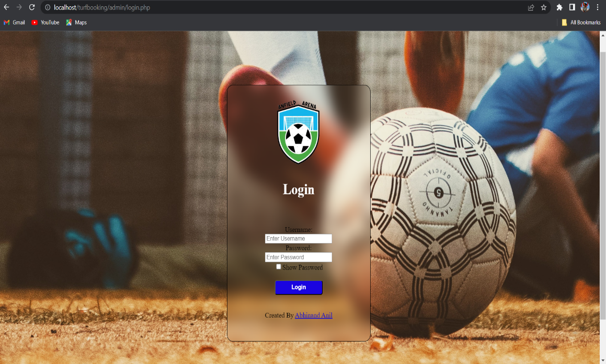

### Dashboard

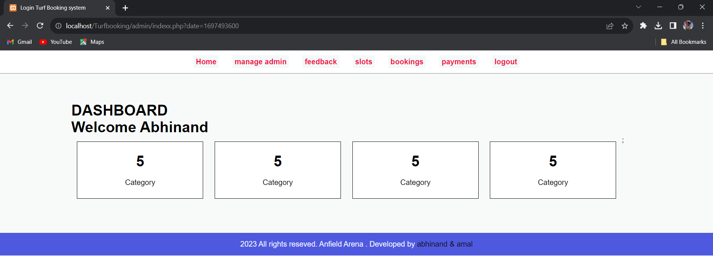

* + **Manage Admin**

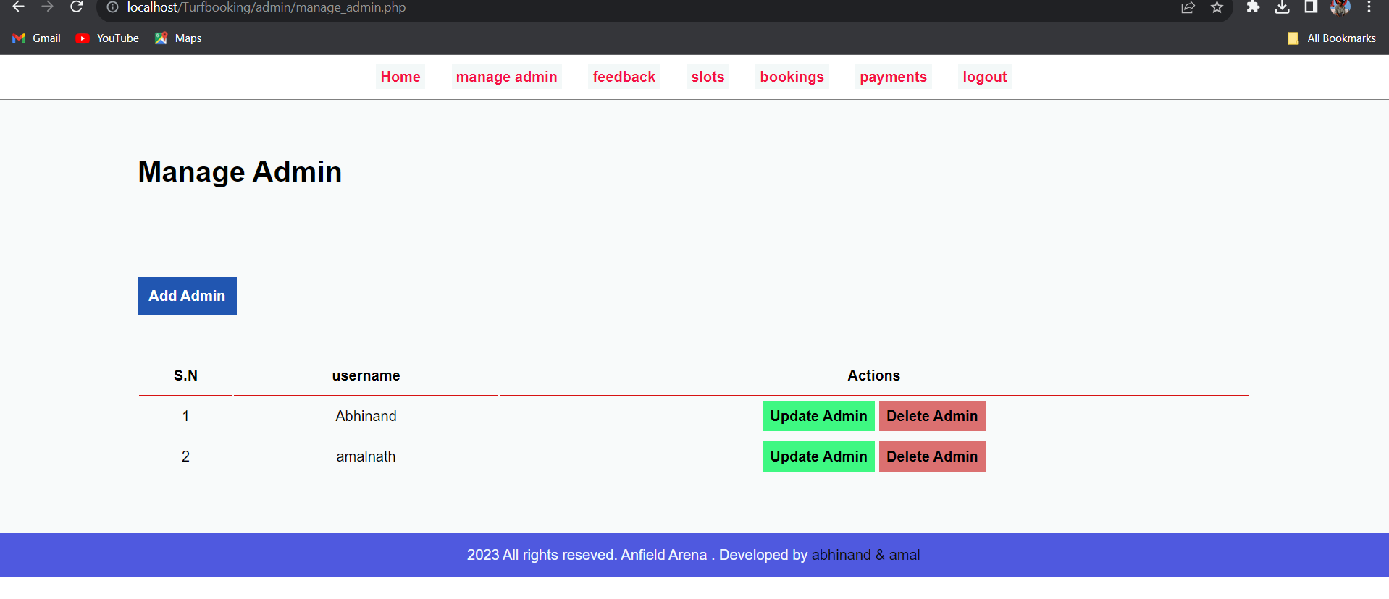

### Manage Slots

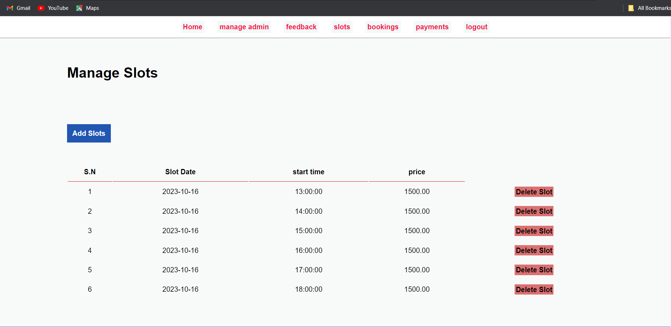

**. Manage Bookings**

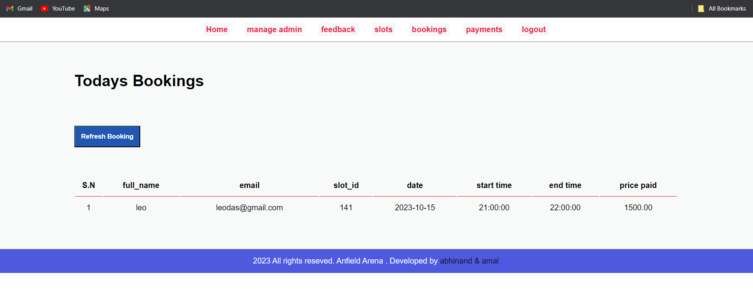

### Manage Feedback

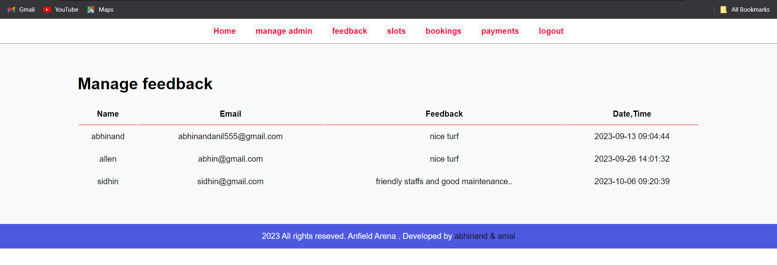

**. Manage Payments**

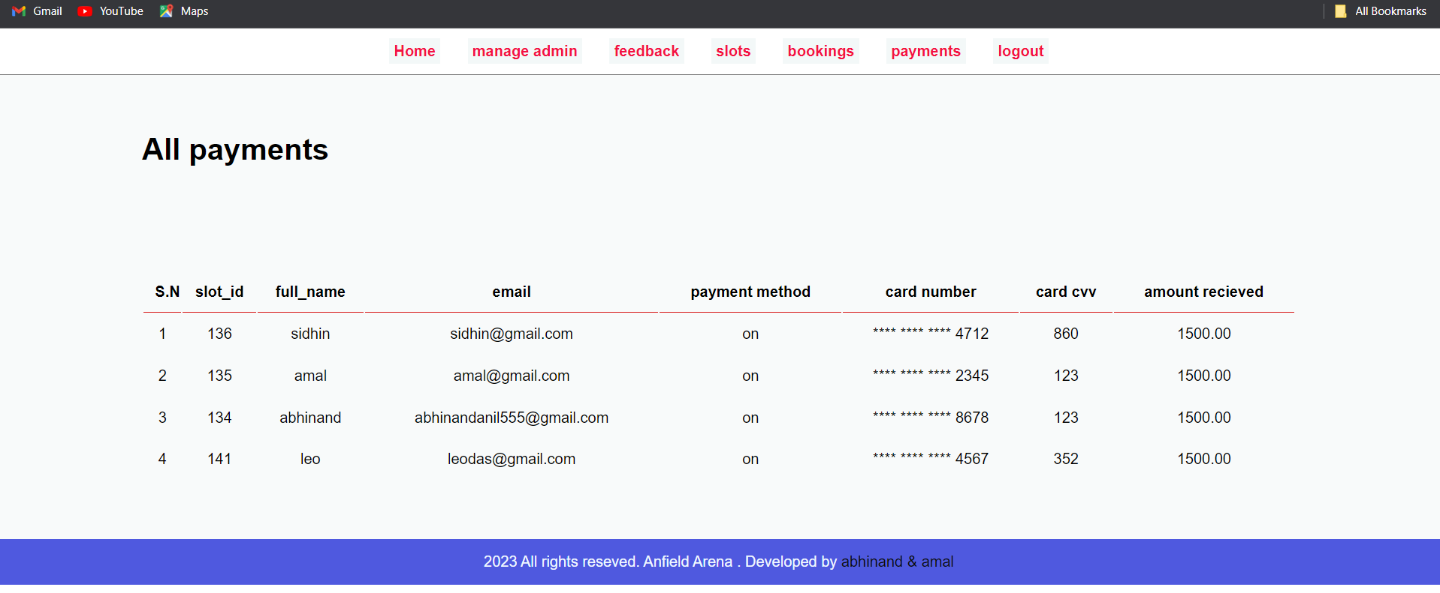

### 2.Customer module

* + **Home**



### Booking

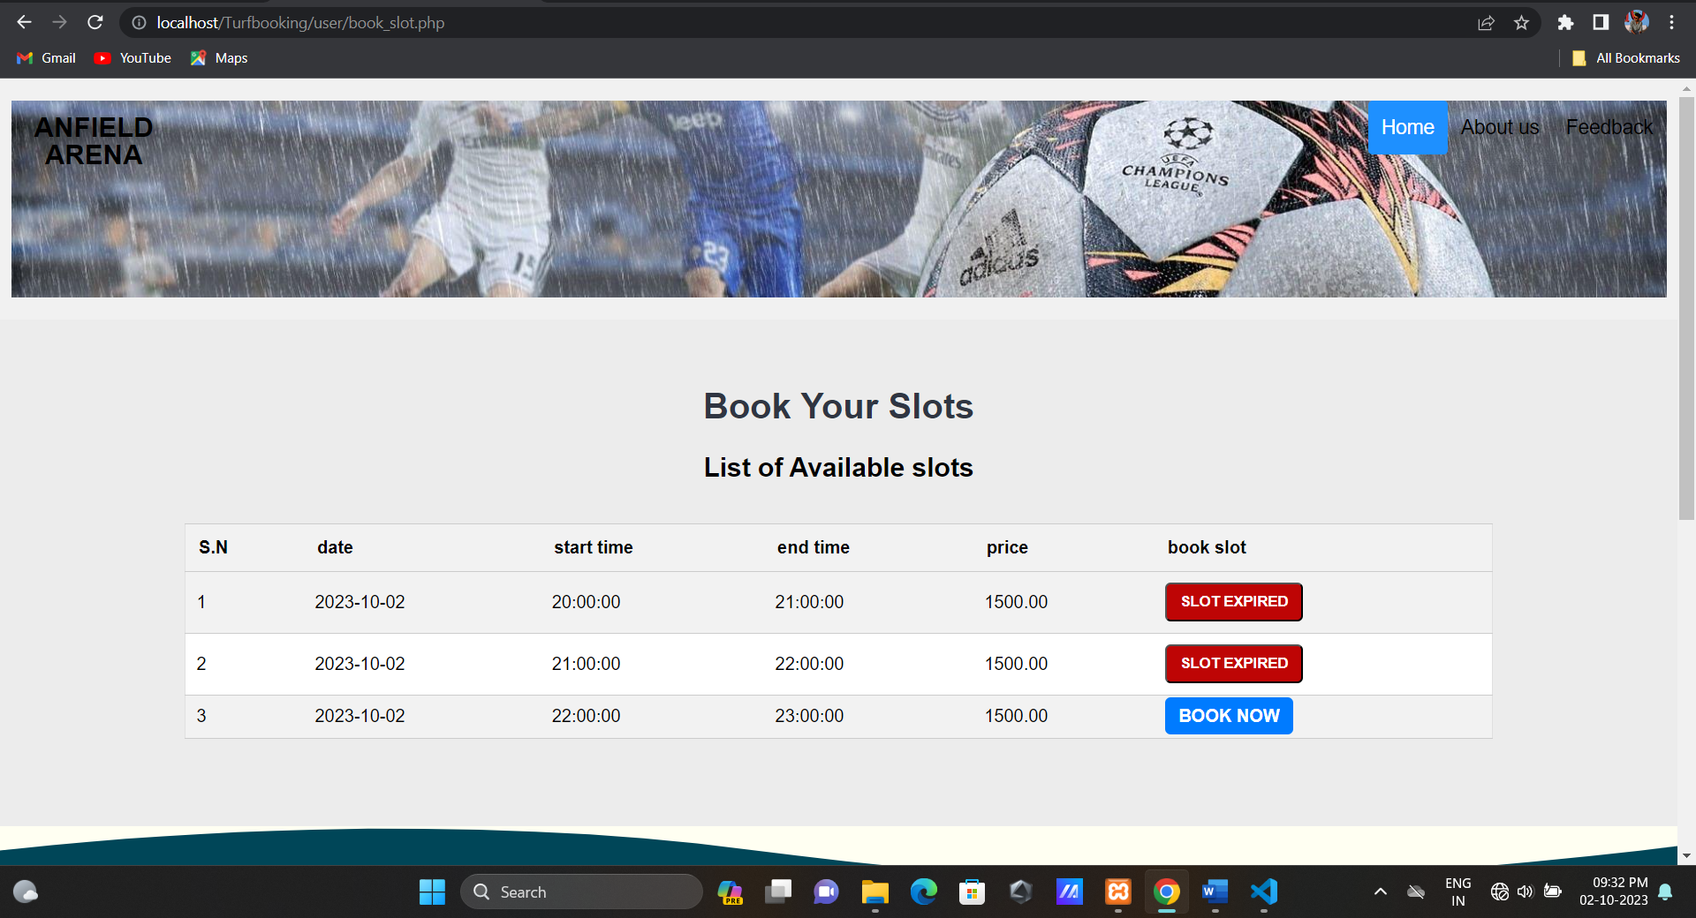

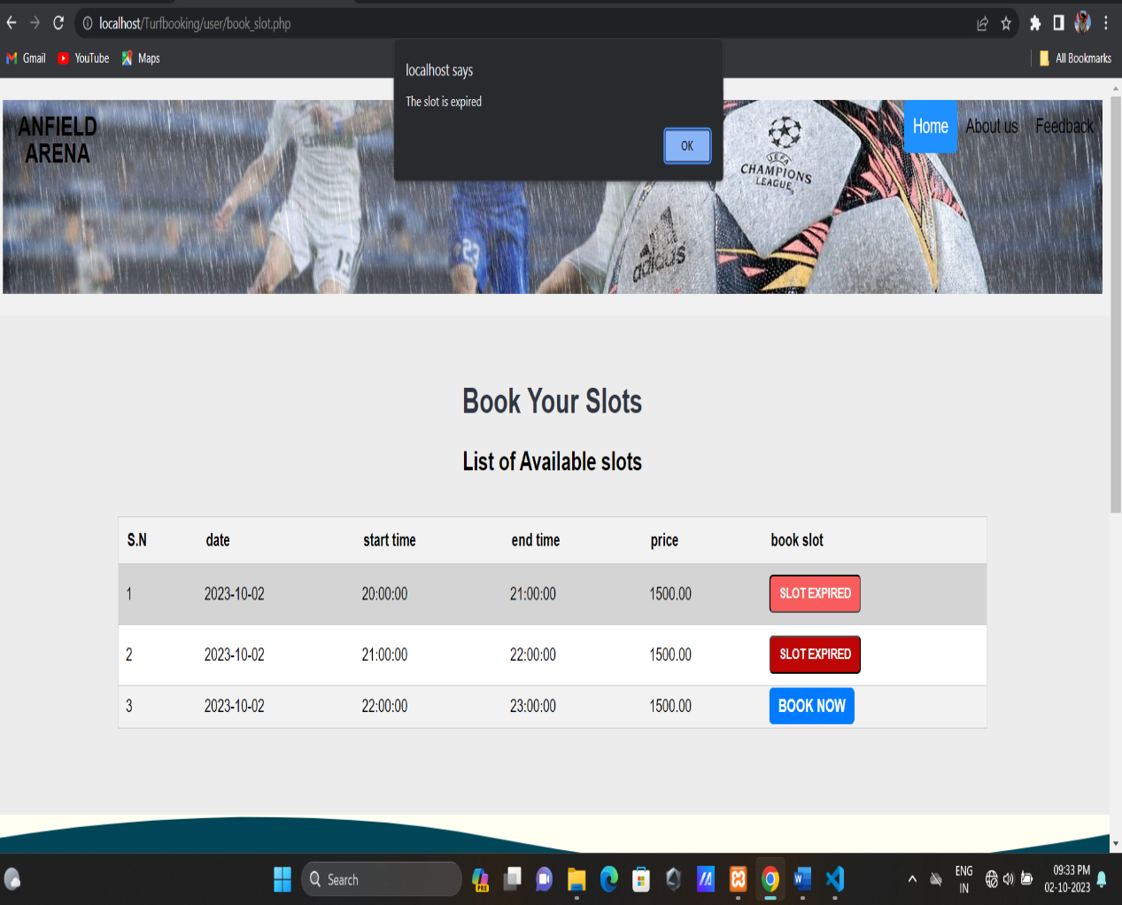

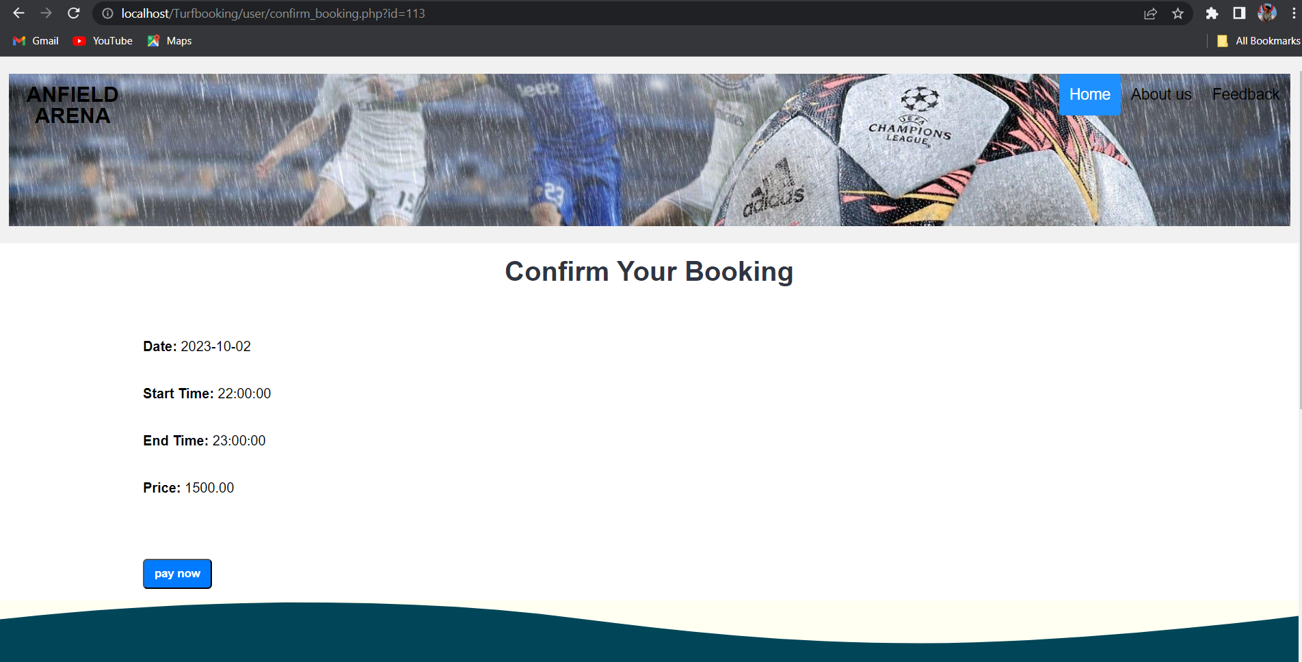

* + **Payment**

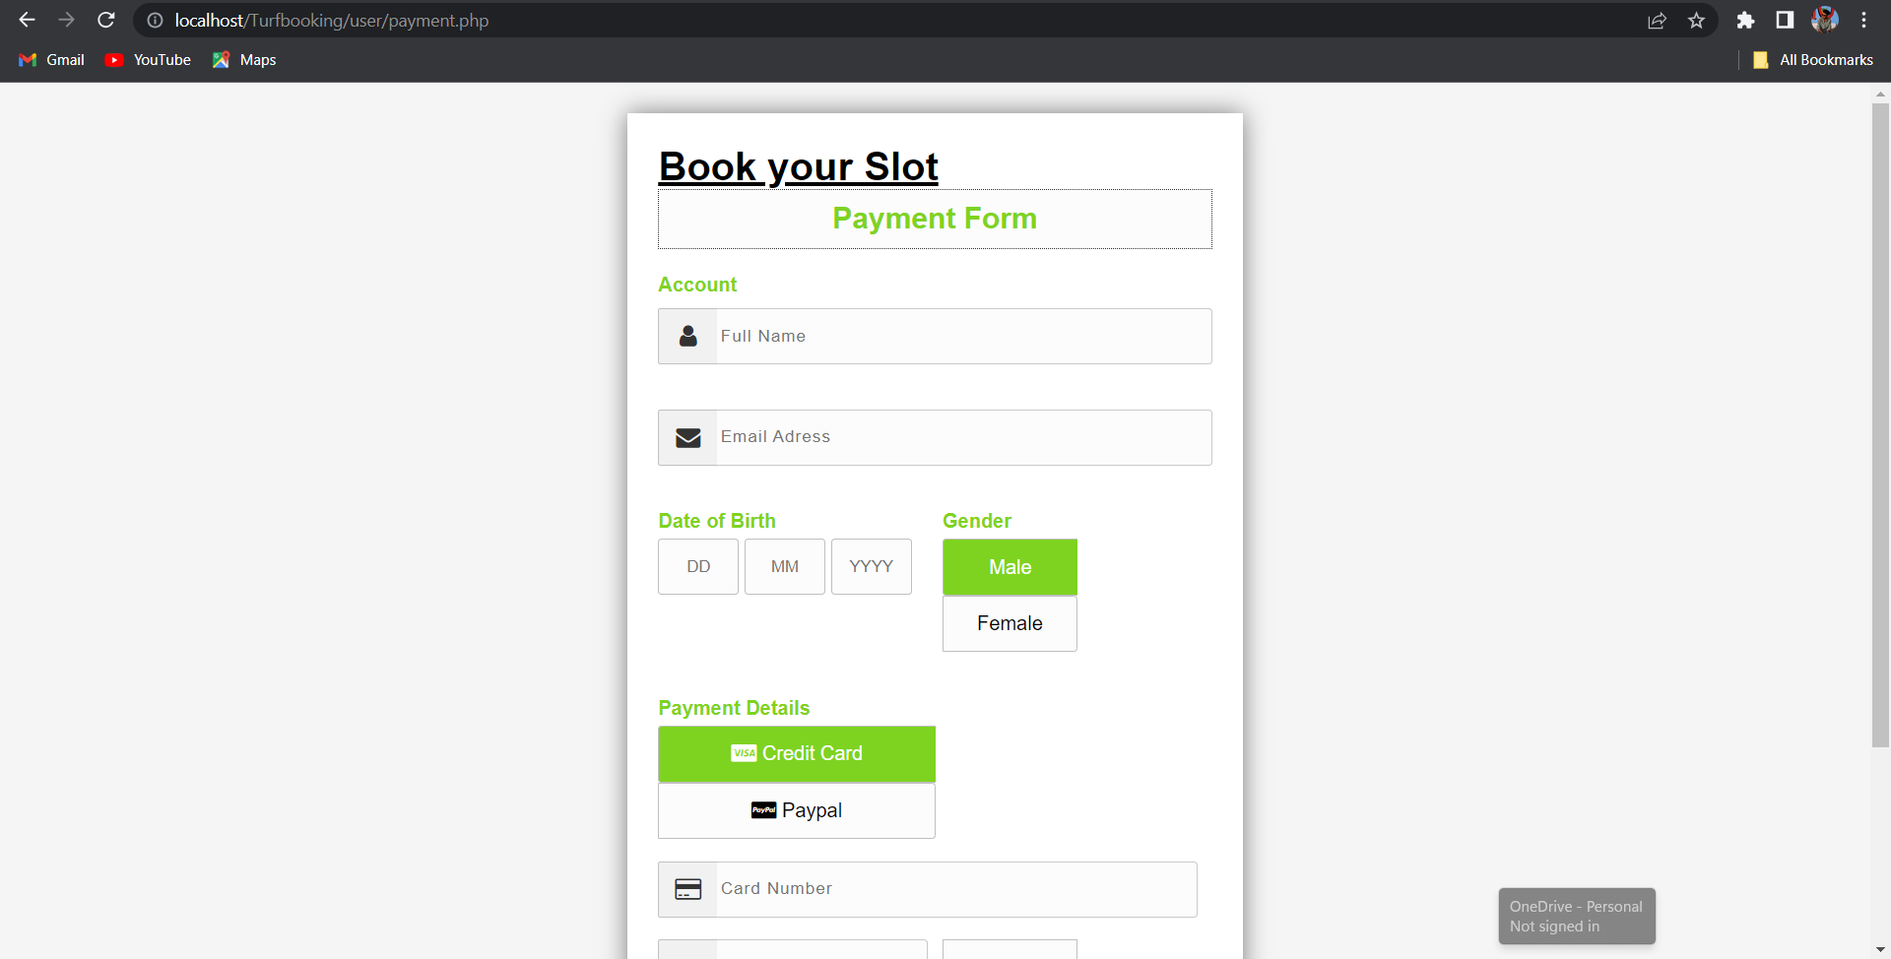

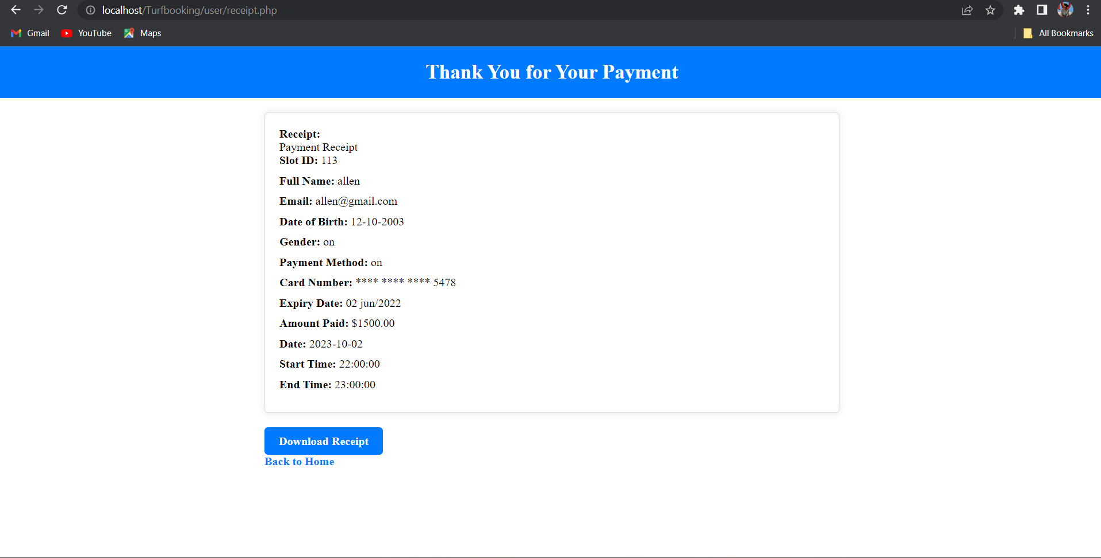

### Feedback

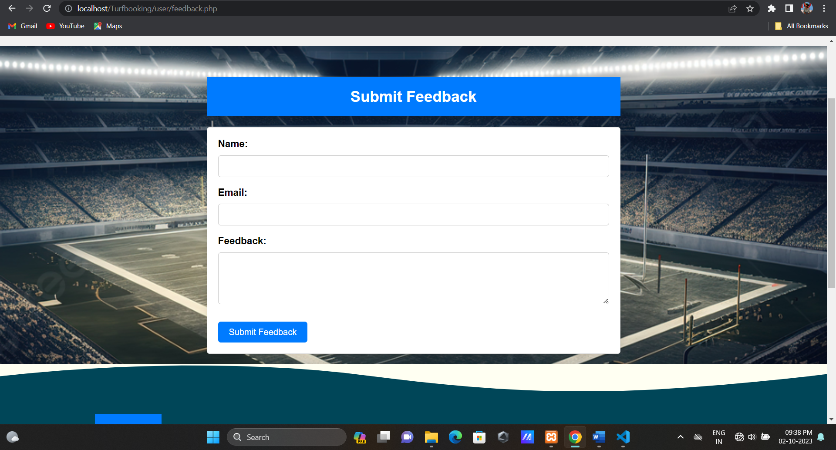

* **About us**

